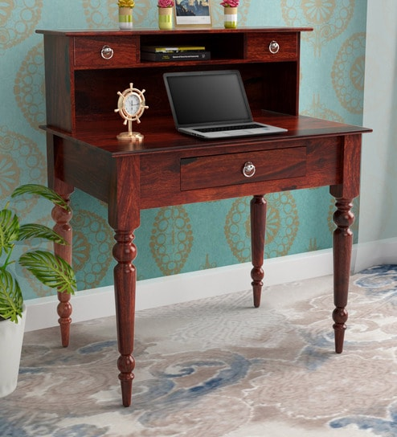

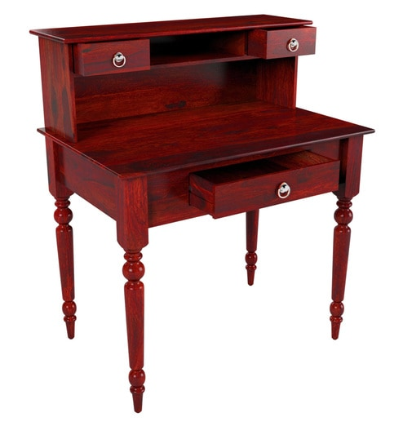

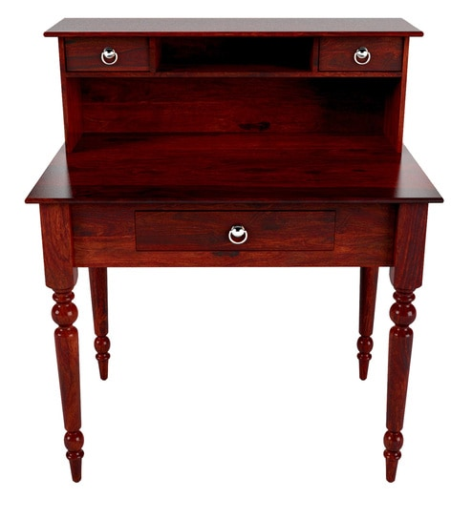
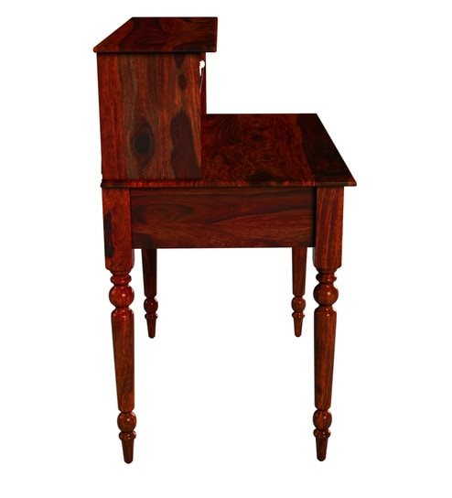
A beautiful blend of elegant turned wooden legs, structured vertical slats and refined brass hardware, the Harleston Collection gives your space a tasteful stance. Available in Provincial Teak & Honey Oak and crafted in Sheesham, here?s one range that pleases one and all.

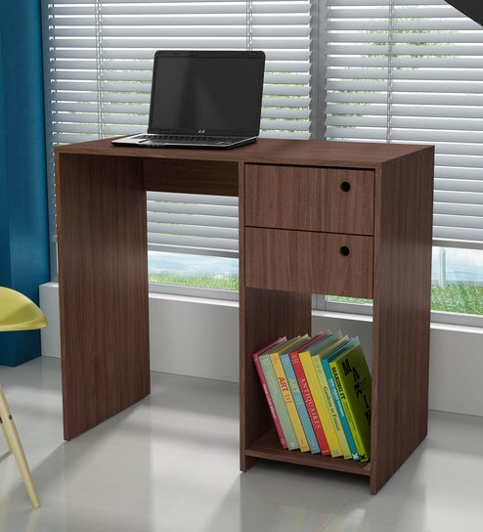

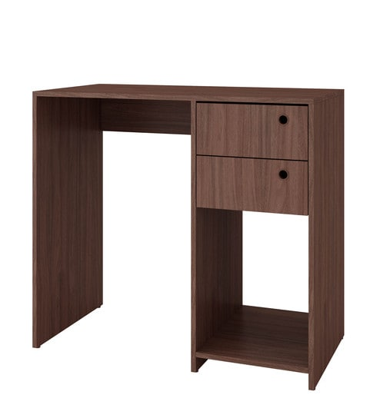

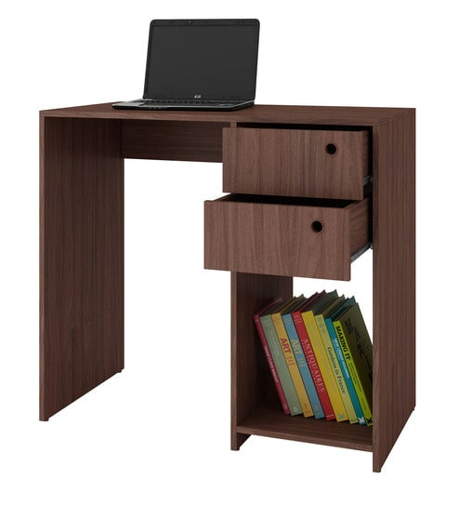
modern furniture thats designed to seamlessly blend with your interiors. Crafted for compact homes, the range is clean and convenient. All the collections have an understated design aesthetic that adapt to any space

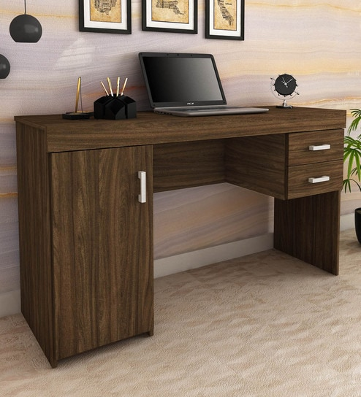
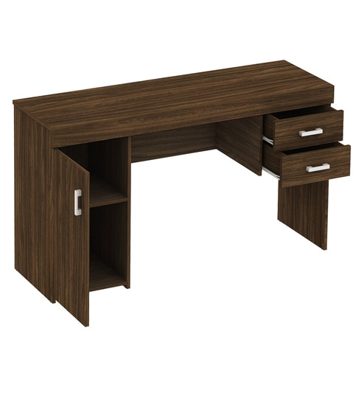

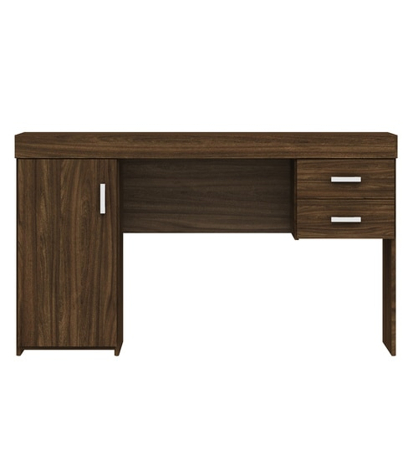
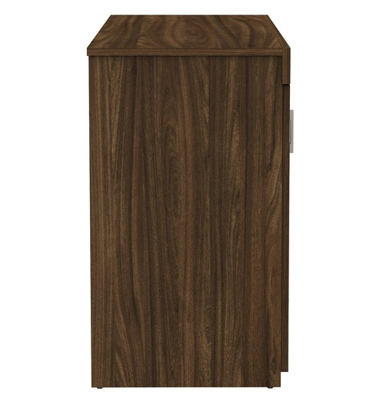
modern furniture thats designed to seamlessly blend with your interiors. Crafted for compact homes, the range is clean and convenient.
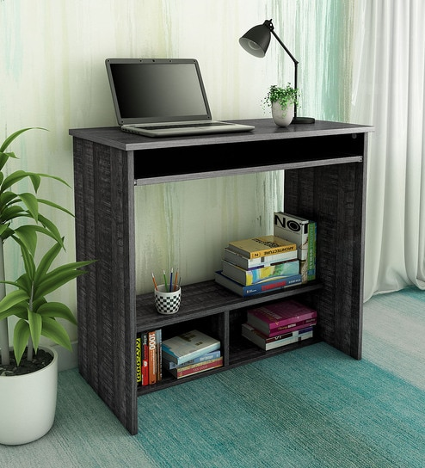

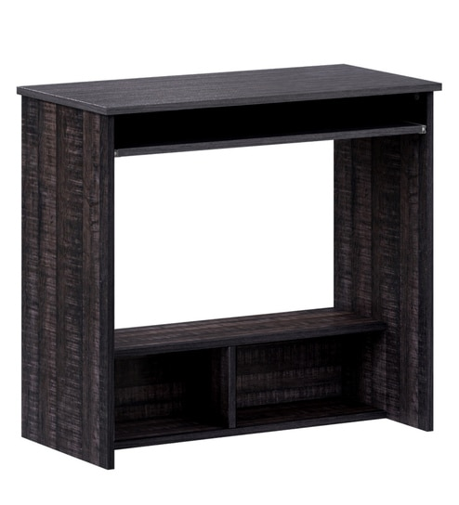
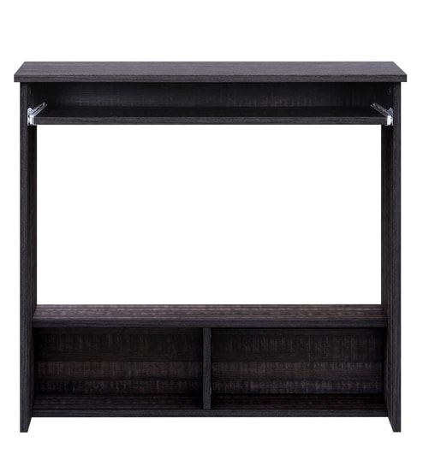
modern furniture thats designed to seamlessly blend with your interiors. Crafted for compact homes, the range is clean and convenient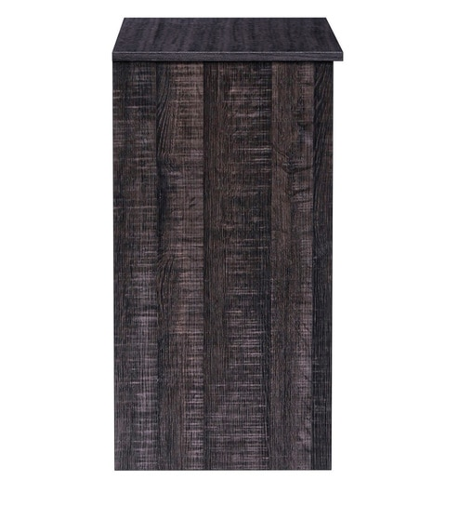

modern furniture thats designed to seamlessly blend with your interiors. Crafted for compact homes, the range is clean and convenient

